1. Create basic template – others will inherit from here

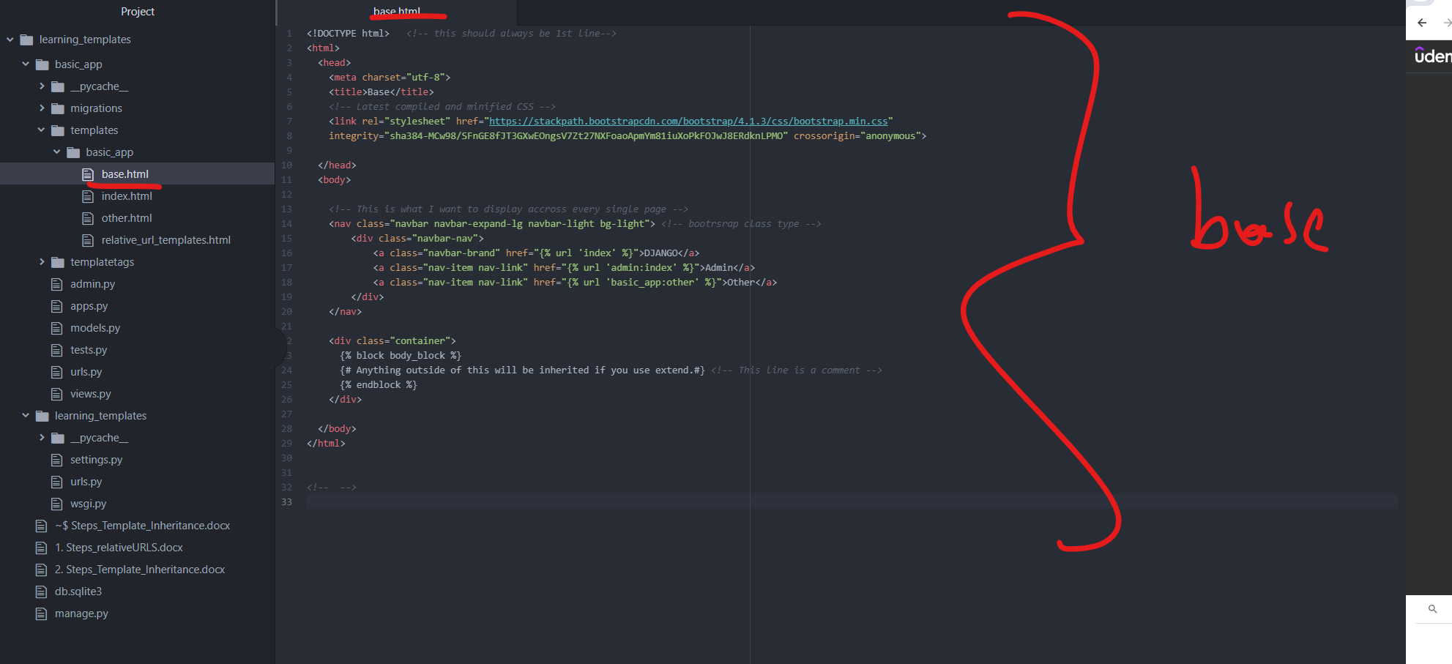

1. Models (or .htmls) that I inherit from the base.hmtl

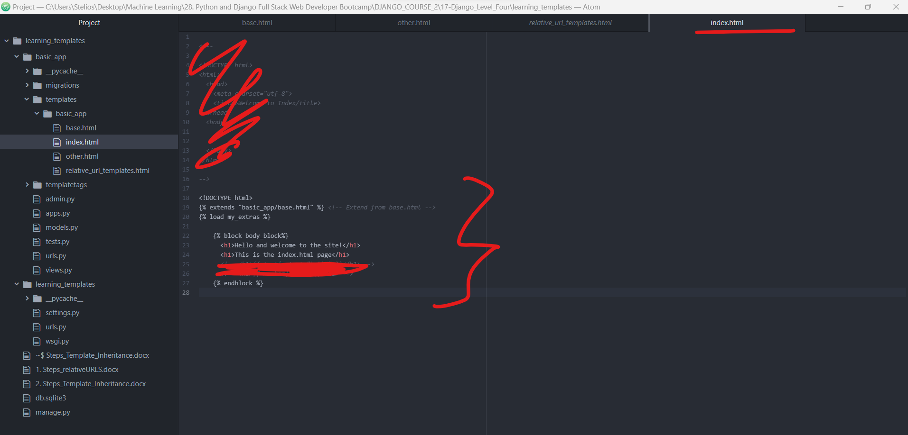

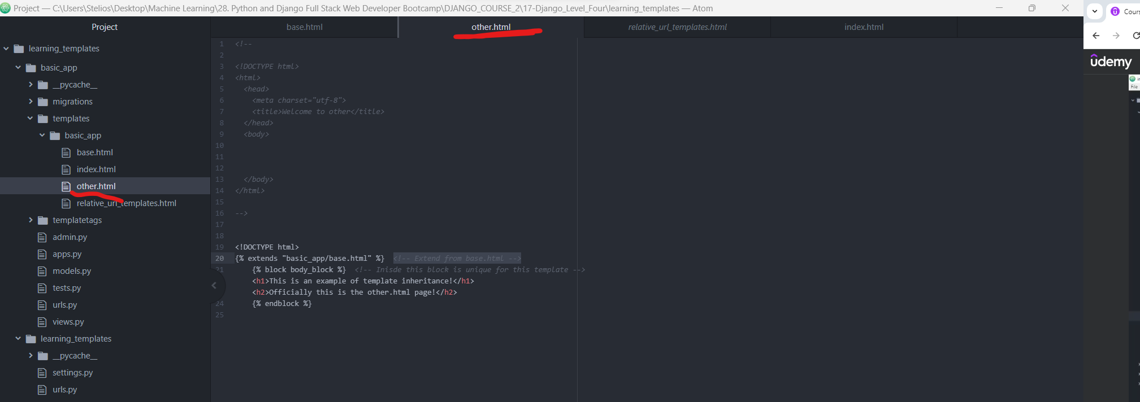

1. Runserver: Check that Django and Other have the same template. Admin html is not inherited from base so its different. We will talk **about Django admin customization** in a future session.

